Code:

|  |
| --- |
|  |
|  | import random  while(True): |
|  | o=random.randint(10,99) |
|  | p=random.randint(10,99) |
|  | if(o > 30 and p > 75): |
|  | print("High Temprature and Humidity of:",o,p,"#","alarm is on") |
|  | elif(o < 35 and p < 65): |
|  | print("Normal Temprature and Humidity of:",o,p,"#","alarm is off") |
|  | break |

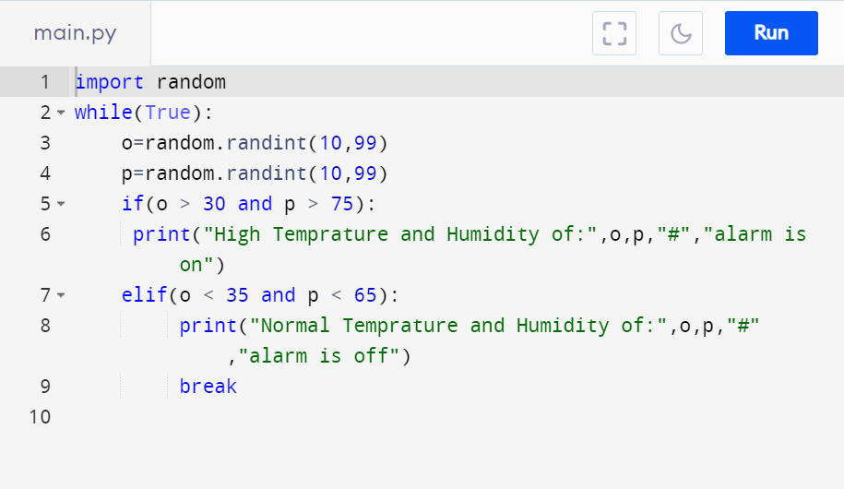

Output:

